Note: As of the date this was written, TY 2018 8606 information has not been published by the IRS nor has TSO been updated for 2018.

IRA non-deductible contributions are made when a deductible contribution is limited by income and/or the taxpayer having a retirement plan. When non-deductible contributions are made, they are tracked on form 8606. When a distribution is taken from an IRA that has had non-deductible contribution, the non-taxable portion of the distribution is calculated on form 8606.

Non-deductible contributions can be made up to the maximum allowable IRA contribution. For tax year 2018, the maximum allowable contribution is $5,500($6,500 if taxpayer is 50 or older yrs of age). The total of all IRA contibutions (deductible, non-deductible and Roth) can not exceed the maximum allowable contribution.

References:
- Instructions for Form 8606
- IRS Pub NTTC Modified 4012 Tabs E-9 and D-36
- IRS Pub 590A

Form 8606 Description
- Part I – For reporting non-deductible contributions as well as distributions
    - Distributions reported here only if there were non-deductible contributions
- Part II – Conversions from traditional IRAs to Roth IRAs– See separate Special Topic
- Part III – Non-qualified distributions from Roth IRAs – Out of Scope unless it is an error and it is a qualified distribution

Reporting Non-Deductible Contributions
- Non-Deductible contributions MUST be reported on Form 8606 Part I
  - Creates a basis for IRA Withdrawals
  - If non-deductible contributions are not reported on the 8606, there is no tax-free benefit on the distribution
- Form 8606 provides cumulative record
  - Non-Deductible Contributions (cost basis) for distributions

Non-Deductible Contributions entered in TaxSlayer (See example for details)
- Enter all IRA contributions (deductible and non-deductible) in Adjustments – IRA Deductions
- Enter non-dedectible contributions in Adjustments - Nondeductible IRAs Form 8606
- Taxpayer must provide amount of the basis for earlier years

IRA Distributions after Previous Years of Non-deductible Contributions (See example for details)
- If there has been non-deductible contribution(s) to an IRA, a portion of the distribution shown on a 1099-R is not taxable.
  - The taxpayer must have the 8606. If non-deductible distributions were taken in the previous year, the 8606 should be part of that return.
  - Complete the 1099-R as you normally would
  - Enter form 8606 in the TaxSlayer search box
  - Complete the 8606 inputs as shown below
  - Go to “Preview Return” and note the amounts in box 13 and box 15 of form 8606
  - Enter the taxable portion in the 1099-R box 2a
  - Enter the amount on the Form 8606 box 13 in the NJ Checklist as adjustments to NJ 1040 box 19b

Example of entering IRA Distributions after previous years of Non-deductible Contributions in TaxSlayer. Includes non-deductible contribution in the same year.

A taxpayer is 61 years old. He has taken a $50,000 distribution from an IRA in which he had made $12,500 in non-deductible contributions in previous years. His total of all his IRAs is $450,000. He has made a non-deductible contribution to and IRA for 2018 of $5,000. He had $32,000 of W-2 income and has a retirement plan at work. There were no other distributions from IRAs. The taxpayers AGI is $80,750.

Step 1 – Enter the 1099-R for the IRA distribution. Leave Box 2 the taxable amount the same as box 1. Complete any other boxes as required from the paper 1099-R. Be sure you check the IRA/SEP/ Simple box” in box 7.

Step 2 – If there are any IRA contributions for the tax year enter them in Adjustments – IRA contributions. TSO will determine if the contributions are deductible or non-deductible based on if the taxpayer has a retirement plan the taxpayer’s AGI.
- Deduction Amount and Modified AGI Limit for Traditional IRA Contributions
  - For 2018, the maximum IRA deduction remains at $5,500 ($6,500 if age 50 or older).
  - For taxpayers who are covered by a retirement plan at work, the deduction for contributions to a traditional IRA is reduced (phased out) if the modified AGI is:
    - More than $101,000 but less than $121,000 for a married couple filing a joint return or a qualifying widow(er) if both spouses are covered by a retirement plan
    - More than $63,000 but less than $73,000 for a single individual or head of household, or
    - Less than $10,000 for a married individual filing a separate return
  - For an IRA contributor who is not covered by a workplace retirement plan and is married to someone who is covered, the deduction is phased out if the couple’s income is between $189,000 and $199,000.

Step 3– Use the Forms Search Box to go to the form 8606 entry screen.

Step 4 - Enter remaining basis (from prior year Form 8606), year-end value of all IRAs (provided by taxpayer), and the amount of the distribution. If there are any non-deductible contributions between 1/1/19 and 4/17/19 enter them also.
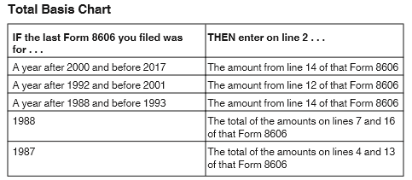

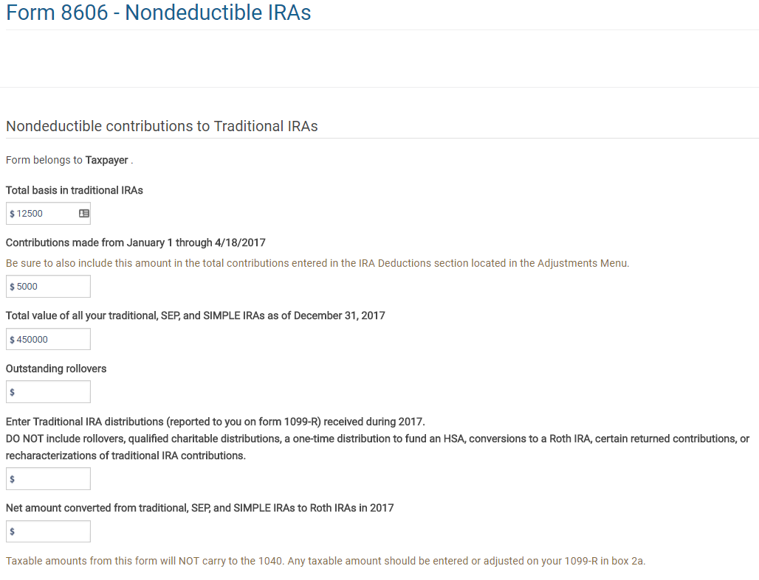
Enter any contributions from Jan. 1, 2019 to Apr. 16, 2019. IRA Deduction worksheet must be completed for this value to carry to the 8606.
Conversions from IRAs to Roth IRAs
Enter basis from previous year’s 8606. See the chart above for the line number on the previous year’s 8606.
Enter all IRA distributions received in the current tax year
50000
Enter the total value of all IRAs at the end of the current tax year
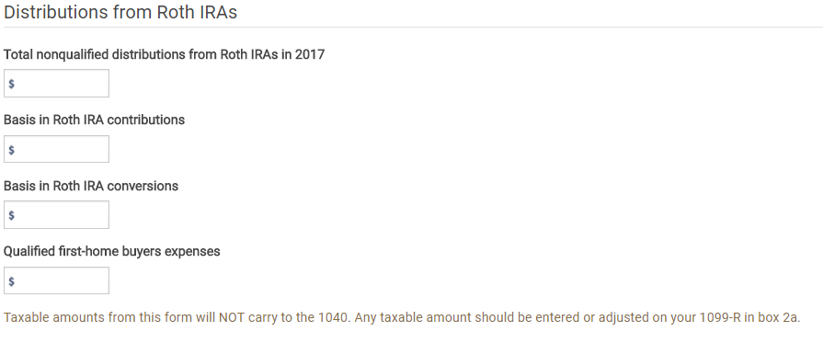
Nonqualified distributions from Roth IRAs are OUT OF SCOPE unless it is an error and it is a qualified distribution

Step 5 – Return to the Adjustments screen and click on the Print icon next to Nondeductible IRAs
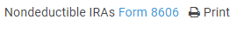
Look at Form 8606, and find the taxable amount of the distribution on Line 15 and the non-taxable portion on line 13.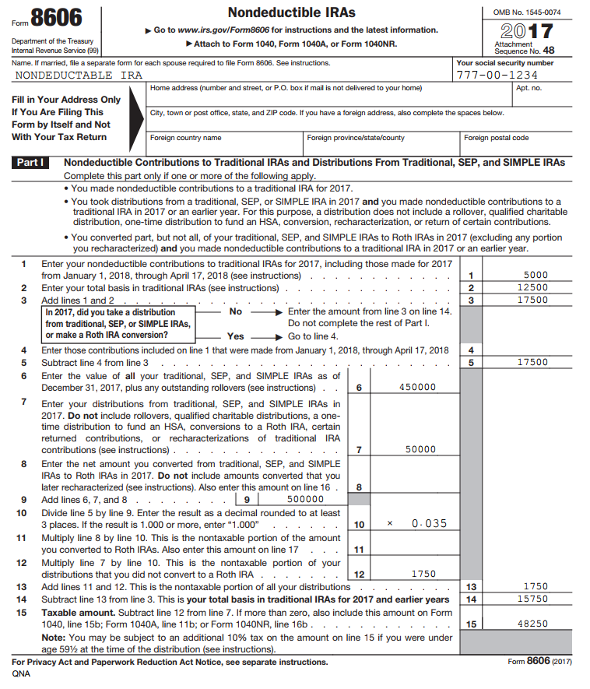
Amount from line 15 is to be entered in the 1099-R Box 2a.
Amount from line 13 to be entered on NJ Checklist as Adjustments to line 20b

Step 6- Go back to the TaxSlayer return. If there is only one IRA distribution, enter the taxable amount (Form 8606 line 15) in Box 2a of the 1099-R. If there is more than one IRA distribution, subtract the nontaxable portion (Form 8606 line 13) from the Box 1 amount on one of the IRAs. Enter the result into Box 2a of that same 1099-R. All the remaining IRAs will be 100% taxable.
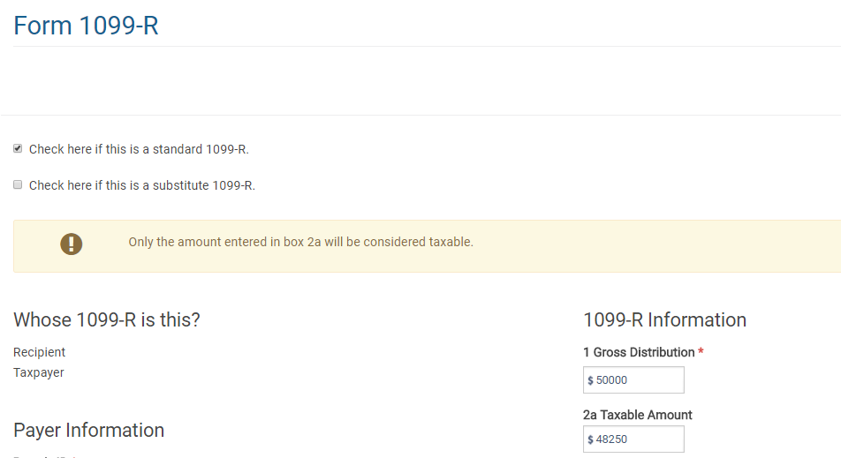
Step 5 – Enter taxable amount in 1099-R box 2a

Step 7 - Enter the non-taxable portion on the NJ Checklist as Adjustments to line 19b.

A second Form 8606 may be required if each spouse has basis in their own IRAs.
Taxable amount from 8606 line 15

e 15
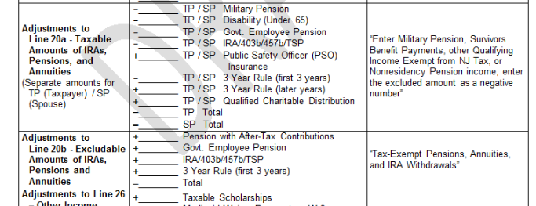
1750
Step 6 - Non-taxable portion to go on NJ Line 20b from 8606 line 13

